
FOR IMMEDIATE RELEASE

Singaporeans are among Asia’s Happiest People

This International Day of Happiness, the first Asia Happiness Index 2013 ranks five countries according to their emotional expressiveness in Social Media

Background
Eden Strategy Institute has designed and launched upon Asia’s first scientifically-driven, independent and objective Happiness Index that spans multiple social media platforms across five Asian countries, to better understand the true levels of happiness on a widespread basis across entire online populations. The Asia Happiness Index (www.edenstrategyinstitute.com/happy) is powered by a proprietary online social media intelligence tracking engine, and covers over 200 million social media accounts.
This initiative is launched on 20 March 2013 to commemorate The International Day of Happiness. Mr. Calvin Chu Yee Ming, Partner of Eden Strategy Institute, elaborates,
“Our advisory work with governments and companies has taught us that true citizen and customer engagement needs to extend beyond providing good service, jobs, or retaining their loyalty. The most successful institutions delight their stakeholders and positively impact their happiness levels on a continuous basis. There have been many surveys on Happiness, but we are excited about this unprecedented opportunity to allow people from different countries to benchmark their true Happiness levels with each other, over time, and in real-time. This is the first and only regional Happiness Index that covers over 200 million online accounts across Asia, and taps into people engaging with each other in their natural states. We were surprised by some of the results, which reveal the national psyche of these countries and will be of strong interest to citizens, policymakers, and businesses alike.”
Key Findings
As of 19 Mar 2013, the Asia Happiness Index ranked the following Asian countries on their happiness levels, with Singaporean expressing themselves as the most happy people:

Country  - Singapore  - Malaysia  - Philippines  - Indonesia  - India | Happiness Index Score  518  245  90  29  11
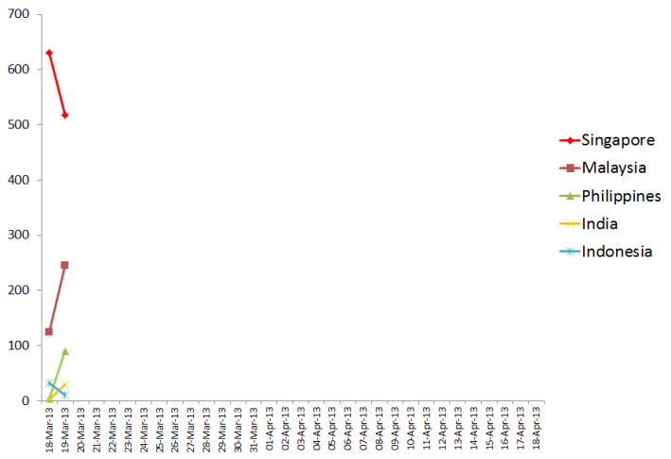
Singapore tops the list despite a looming perception of dissatisfaction over rising costs of living, recent infrastructure breakdowns, and the style of governance in the mass media. Any such negative sentiment appears to be voiced by a vocal minority, while the majority of Singaporeans continue to build on the Singaporean dream of self-actualisation, meritocracy, safety, and efficiency in society. While Singaporeans can be reticent, they are particularly vocal during festive periods and special occasions like birthdays or anniversaries, and express their encouragement for each other especially among the youth. Singaporeans love to send funny pictures or pictures of food, as a means of reaching out and sharing.
Malaysians actively make decisions to live life to the fullest. They attach different values to various dimensions of life, such as work, religion, or leisure. While their favourite hobbies of food, shopping, family, sports, and nature may be similar to other Asian countries, they take a unique community approach whether it might be for soccer, politics, or late night suppers at the numerous roadside Indian “Mamak kopitiams”. Malaysians are deliberate about making sure they do not overstress, although we’ve observed that the current political dynamics are creating some negative sentiment.
In the Philippines, happiness comes from a sense of large, extended families, where the entire village chips in to raise a child. Filipinos like to feel like they belong, and everyone watches after each other as they greatly value companionship and the sense of brotherhood. When they address their elders as “auntie” or “uncle”, they really feel an affinity. Being a mostly Catholic country, many Filipinos have a predisposition to look for the best in everyone. They are taught from young to be kind, to support the underdog, find joy in hard work, and smile at hardships.
“Filipinos are very lighthearted, and we’ve learnt not to take things too seriously,” says Ms. Castellina Reyes, a Singapore-based Filipino Managing Director of a multinational company.
“In fact, when my colleagues and I are most stressed out, we banter around and sometimes break into song! Our Singaporean friends may think that we are a little crazy,” she says.
In India, we’ve observed that traditions play a major role on happiness. The institution of large families living together creates strong social support. Parents earn money for their children, and express much hope for their future. Families make joint decisions on most matters, and play the main role in the many festive occasions that India enjoys. There is also a strong sense of patriotism, with many uniting over sports such as cricket. There are some general concerns over violence, crime, infrastructure, the lack space, and public health.
Indonesia espouses a strong spirit of togetherness as a historical outcome of strength in solidarity across its 13,000 islands. This translates today into a helpful communal spirit of "gotong royong". Many Indonesians have learnt to appreciate the small things in life, and identify with each other through shared habits such as local slangs, mannerisms, schools, or a common love for food. The local cuisine continually comes up as a source of pride and a reason to get together, a reminder of the richness of the land. Religion also plays a part, with a focus on moderation and contentment. Indonesians most aspire to live in harmony within a multicultural environment, in a country that is safe and run by an honest government.

• • • • •

About Eden Strategy Institute
Eden Strategy Institute is Asia’s leader in Social Innovation. Its distinctive approach to sustainable advantage helps leading global corporations, governments, and non-profit organizations design new growth platforms, operations, products, and services, and align them with market forces and developmental opportunities. Eden has helped bring disruptive innovations that generate financial value from creating social impact, such as in the areas of active ageing, educational innovation, emerging middle class technologies, energy efficiency, and healthcare. Learn more about Eden at edenstrategyinstitute.com

Media Contact:
Ankita Gupta
Asia-Pacific Media Relations
Eden Strategy Institute
E: media@edenstrategyinstitute.com
T: +65 9323 2404
W: www.edenstrategyinstitute.com

APPENDIX: DETAILED METHODOLOGY

A. Operationalizing Happiness
Researchers recognise the need for scientific rigor in serious inquiry into Happiness. Traditionally, Happiness studies have relied on the self-reporting method, yet the accuracy of self-reporting methods is known to be limited by memory bias, central tendency bias, acquiescence bias, and social desirability bias. It can further be misrepresented by the way survey questions are framed by the researchers.
The latest scientific research into Happiness offers a set of ‘markers’ that lead to social and individual well-being. These include factors such as strong and frequent social ties, good health, a sense of purpose through meaningful work, and so on. This was the set of Happiness Markers used in the Asia Happiness Index 2013:
- Acts of kindness  - Coping ability  - Exercise  - Flow states  - Forgiveness | - Gratitude  - Laughter  - Meditation  - Optimism  - Personal growth | - Self-satisfaction  - Sense of fulfillment / meaning / creating  - Social support  - Spirituality

B. Examples of supporting studies, for just ‘Optimism’ & ‘Gratitude’.
Emmons, R.A., and Shelton, C.M. (2002). Gratitude and the science of positive psychology. In Snyder, C.R., and Lopez, S.J. (eds.). Handbook of Positive Psychology (pp. 459-471). Oxford: Oxford University Press
Emmons, R. A., and McCullough, M.E. (2003). Counting blessings versus burdens: An experimental investigation of gratitude and subjective well-being in daily life. Journal of Personality and Social Psychology, 84: 377-389.
McCullough, M.E., Tsang, J., and Emmons, R.A. (2004). Gratitude in intermediate affective terrain: Links of grateful moods to individual differences and daily emotional experience. Journal of Personality and Social Psychology, 86: 295-309.
Scheier, M.F., and Carver, C.S. (1993). On the power of positive thinking: The benefits of being optimistic. Current Directions in Psychological Science, 2:26-30.
Segerstrom, S.C. (2001). Optimism, goal conflict, and stressor-related immune change. Journal of Behavioural Medicine, 24: 441-467
Tiger, L. (1979). Optimism: The Biology of Hope, New York: Simon & Schuster.
Watkins, P.C., Grimm, D.L. and Kolts, R. (2004). Counting your blessings: Positive memories among grateful persons. Current Psychology: Developmental, Learning, Personality, Social, 23: 52-67.

C. Specific search terms
We further defined each Happiness Marker with a full range of descriptive lexicons, in English as well as relevant local languages (Chinese, Bahasa Indonesian, Malay, Hindi, Tamil, and Tagalog). For example specific search terms in English for Optimism & Gratitude included:
- “anticipation”  - “am sure”  - “confident that”  - “encouraged”  - “expecting”  - “grateful” | - “hopeful”  - “hoping”  - “ideally”  - “no doubt”  - “optimistic”  - “positive” | - “really hope”  - “thank you”  - “thanks”  - “the best”

D. Social Media Search Engine
Automated Sentiment Response algorithms was used to pick up each term from a comprehensive range of social media platforms (e.g. Facebook, Linkedin, Twitter, blogs, websites, online forums) and perform counts of each term. These counts were calibrated using semantic logic to pick up language differences, cultural skews, sarcasm, etc.

E. Final data adjustments for comparisons
To derive the final Happiness Index score, the total counts per country were rebased against the Social Media population in each country, obtained from sources such as Social Bakers and Semiocast. This allowed us to control for differences in population across countries, in order to allow a fair representation of how many comments each individual would create.

